

|  |  |  |  |  |  |  |  |  |
| --- | --- | --- | --- | --- | --- | --- | --- | --- |
|  | | | | | | | | |
|  | | Sequence Diagrams | | | | |  | |
|  |  | | | | | | |  |
|  | | | |  | |  | | |
|  | | | | Muhammad Talha(Lead)Zohaib ZafarAbdul RehmanGroup 12 | |  | | |
|  | | | | Date24 March 2025Course titleSoftware ConstructionTeacher’s NameDr. Onaiza Maqbool | |  | | |
|  | | |  | |  | | | |

**Name: Abdul Rehman**

**Reg. No: 04072312041**

**System Sequence Diagram**

**(Manage hardware Specifications)**

The Manage Hardware Specifications use case allows the Manager to update computer hardware details. The Manager navigates to the hardware specifications page, selects a computer, and updates its specs (e.g., CPU, RAM). The system validates and saves the changes, confirming the update. This ensures accurate and up-to-date hardware records.

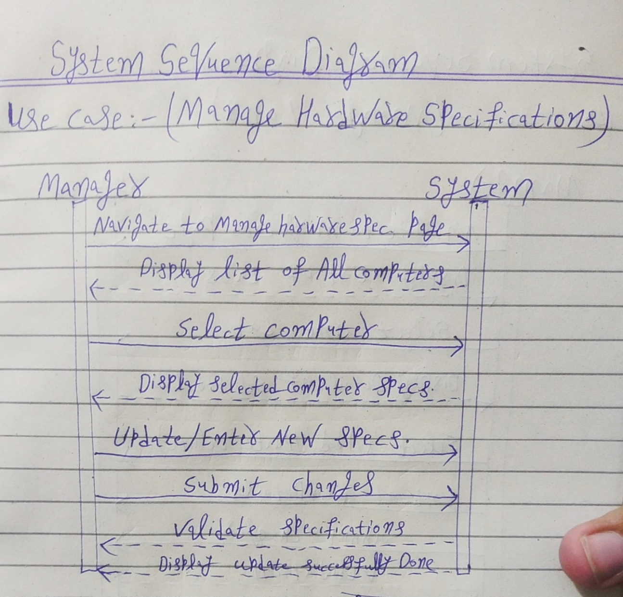

**System Sequence Diagram**

**(Manage Labs)**

The Manage Labs use case allows the Manager to handle laboratory details. The Manager navigates to the labs page, selects a lab, and can add, update, or delete lab information. After submitting changes, the system validates and updates the details, confirming the action. This ensures accurate and efficient lab management.

